- System Data Structure Design
As a subsystem to achieve the function of sharing resource and dealing with homework, our subsystem has its own database to manage different kinds of files and keep its security. However, some tables in the database are shared from the main system to make sure that the final system won’t have several tables to fulfill the same function, e.g. the account information storge. This System Data Structure could excellently support the packaged control command of database programming, which makes our subsystem adapt to changes.
5.1 Concept Structure Design
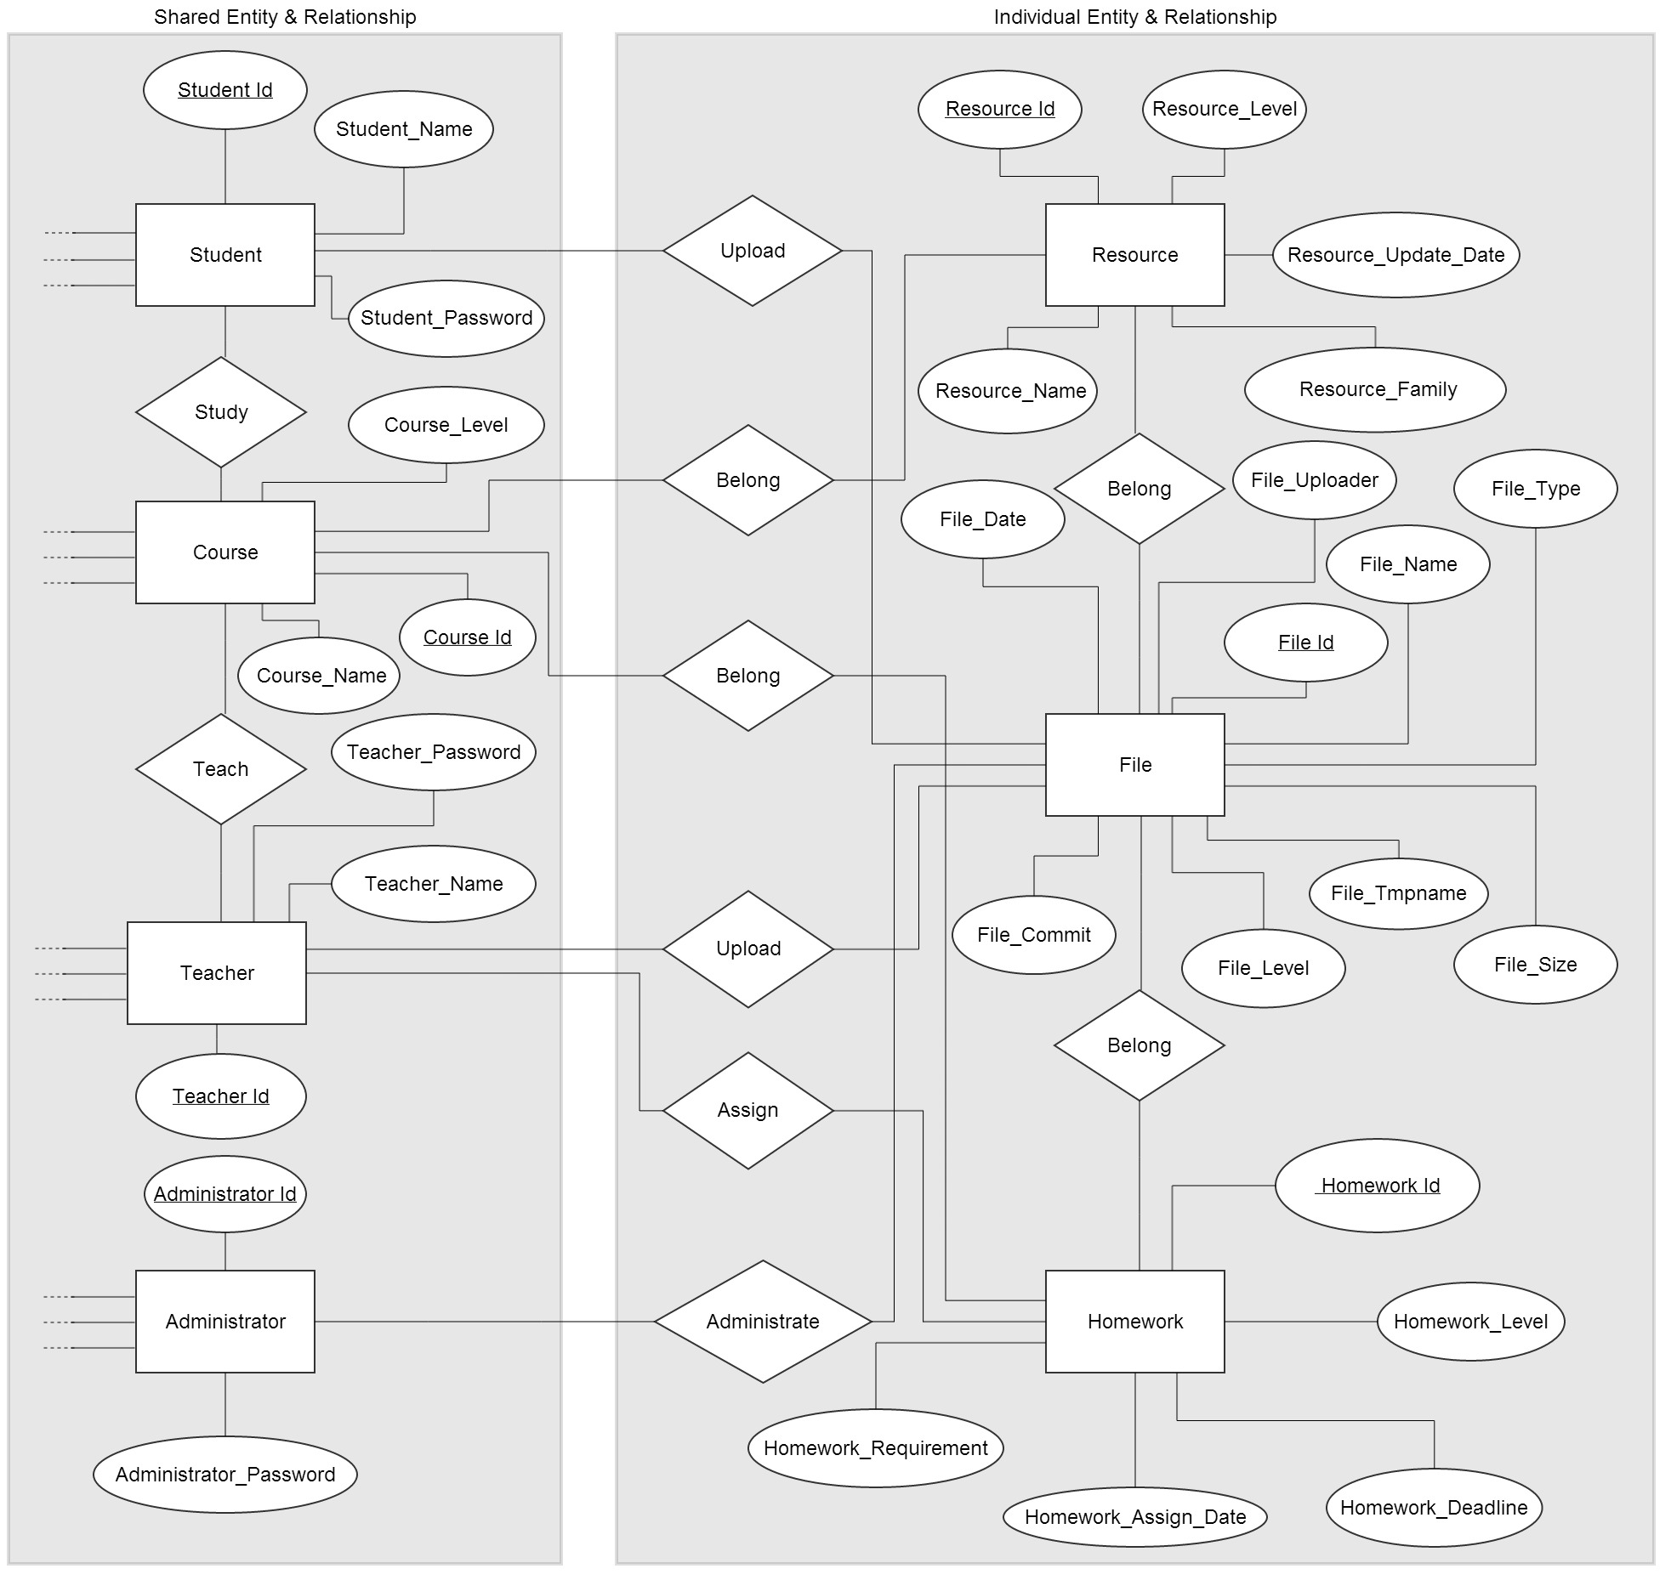
5.2 Logical Structure Design
Notes:“...”implies that this schema may have other attributes which won’t be used in the Resource Sharing Subsystem.

Shared Schemata:
Student Account: Student (Student Id, Student_Name, Student_Password, ...)
Teacher Account: Teacher (Teacher Id, Teacher_Name, Teacher_Password, ...)
Course Information: Course (Course Id, Course_Name, Course_Level, ...)
Administrator Account: Administrator (Administrator Id, Administrator_Password, ...)
Studying Relationship: Study (foreign key Student_Id, foreign key Course_Id)
Teaching Relationship: Teach (foreign key Teacher_Id, foreign key Course_Id)

Individual Schemata:
File Information: File (File Id, File_Date, File_Name, File_Type, File_Size, File_Tmpname, File_Level, File_Commit, File_Uploader)
Homework Information: Homework (Homework Id, Homework_Level, Homework_Deadline, Homework_Assign_Date, Homework_Requirement)
Resource Information: Resource (Resource Id, Resource_Level, Resource_Update_Date, Resource_Family, Resource Name)
Affiliation Relationship between File and Resource: File_Belong_Resource (foreign key File_Id, foreign key Resource_Id)
Affiliation Relationship between File and Homework: File_Belong_Homework (foreign key File_Id, foreign key Homework_Id)
Affiliation Relationship between Resource and Course: Resource_Belong_Course (foreign key Resource_Id, foreign key Course_Id)
Affiliation Relationship between Homework and Course: Homework_Belong_Course (foreign key Homework_Id, foreign key Course_Id)

5.3 Physical Structure Design
Notes:“...”implies that this schema may have other attributes which won’t be used in the Resource Sharing Subsystem.

- Student Account:
Field | Data Type | Can’t  be null | Primary  key or not | Notes
Student_Id | int | Y | Y | Id of student
Student_Name | varchar(20) | Y | N | Name of student
Student_Password | varchar(20) | Y | N | Password of student
... | ... | ... | ... | ...

- Teacher Account:
Field | Data Type | Can’t  be null | Primary  key or not | Notes
Teacher_Id | int | Y | Y | Id of teacher
Teacher_Name | varchar(20) | Y | N | Name of teacher
Teacher_Password | varchar(20) | Y | N | Password of teacher
... | ... | ... | ... | ...

- Course Information:
Field | Data Type | Can’t  be null | Primary  key or not | Notes
Course_Id | int | Y | Y | Id of course
Couser_Name | varchar(20) | Y | N | Name of course
Course_Level | int | Y | N | Level of course to control the visibility of files under it
... | ... | ... | ... | ...

- Administrator Account:
Field | Data Type | Can’t  be null | Primary  key or not | Notes
Administrator_Id | int | Y | Y | Id of administrator
Administrator_  Password | varchar(20) | Y | N | Password of administrator
... | ... | ... | ... | ...

- Studying Relationship:
Field | Data Type | Can’t  be null | Primary  key or not | Notes
Student_Id | int | Y | N | Id of student
Course_Id | int | Y | N | Id of course

- Teaching Relationship:
Field | Data Type | Can’t  be null | Primary  key or not | Notes
Teacher_Id | int | Y | N | Id of teacher
Course_Id | int | Y | N | Id of course

- File Information:
Field | Data Type | Can’t  be null | Primary  key or not | Notes
File_Id | int | Y | Y | Id of file
File_Date | date | Y | N | The submit time
File_Name | varchar(30) | Y | N | The name of name
File_Type | int | Y | N | 1 as resource,  2 as homework
File_Size | int | Y | N | Size of file
File_Tmpname | varchar(30) | Y | N | Temp name of file in server
File_Level | int | Y | N | Level of file to control the visibility
File_Commit | varchar(100) | N | N | Commit of file, added when it is submitted
File_Uploader | char+int | Y | N | Point out who uploaded this file

- Homework Information:
Field | Data Type | Can’t  be null | Primary  key or not | Notes
Homework_Id | int | Y | Y | Id of homework
Homework_Level | int | Y | N | Level of homework to control the visibility of file under it
Homework_  Deadline | varchar(30) | Y | N | The deadline of homework
Homework_  Assign_Date | Date | Y | N | Date of when the homework is assigned
Homework_Requirement | Varchar(200) | N | N | Commit or requirements from the people who assign it

- Resource Information:
Field | Data Type | Can’t  be null | Primary  key or not | Notes
Resource_Id | int | Y | Y | Id of resource
Resource_Family | varchar(30) | N | N | Symbolize the type of resource for search
Resource_Name | varchar(30) | Y | N | The name of resource
Resource_Update_Date | date | Y | N | The last update date
Resource_Level | int | Y | N | Level of resource to control the visibility of file under it

- Affiliation Relationship between File and Resource:
Field | Data Type | Can’t  be null | Primary  key or not | Notes
File_Id | int | Y | N | Id of file
Resource_Id | int | Y | N | Id of resource

- Affiliation Relationship between File and Homework:
Field | Data Type | Can’t  be null | Primary  key or not | Notes
File_Id | int | Y | N | Id of file
Homework_Id | int | Y | N | Id of homework

- Affiliation Relationship between Resource and Course:
Field | Data Type | Can’t  be null | Primary  key or not | Notes
Resource_Id | int | Y | N | Id of resource
Course_Id | int | Y | N | Id of course

- Affiliation Relationship between Homework and Course:
Field | Data Type | Can’t  be null | Primary  key or not | Notes
Homework_Id | int | Y | N | Id of homework
Course_Id | int | Y | N | Id of course

